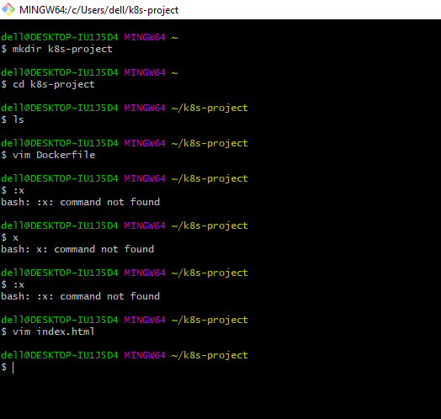

**Create the Docker file and save**

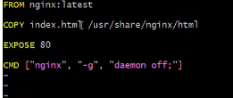

**Now create index.html file using command vim index.html**

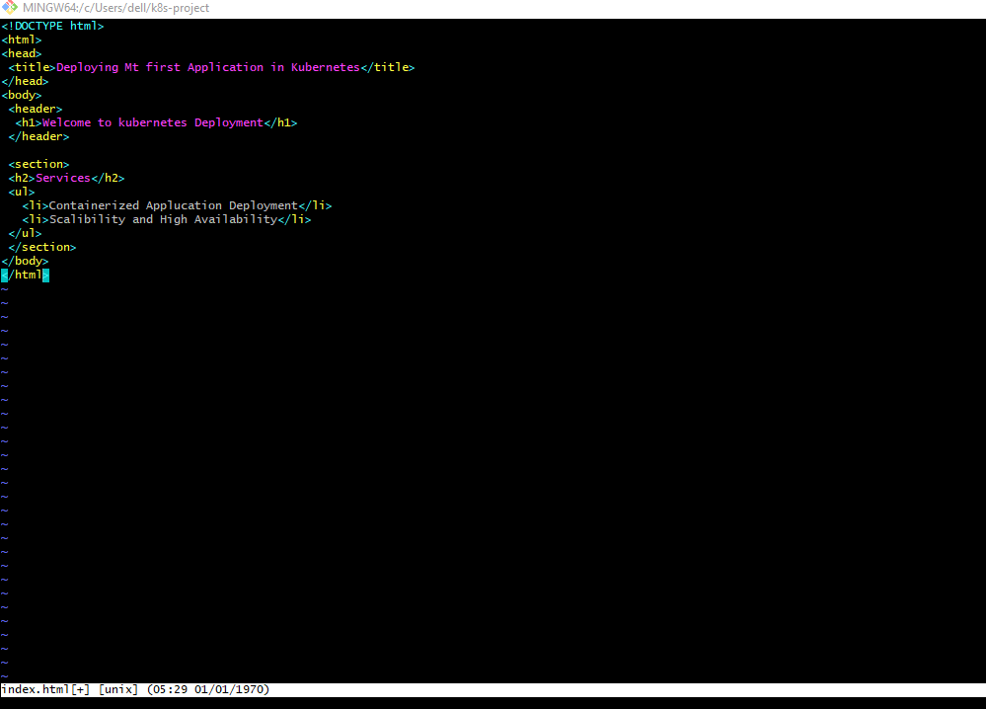

**Create the custom image**

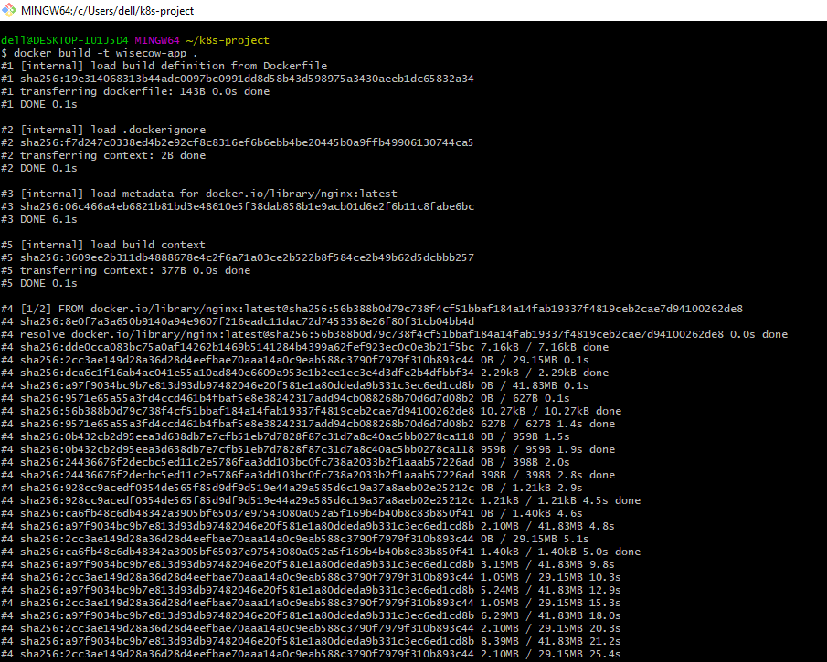

**Run the docker images using command docker images**

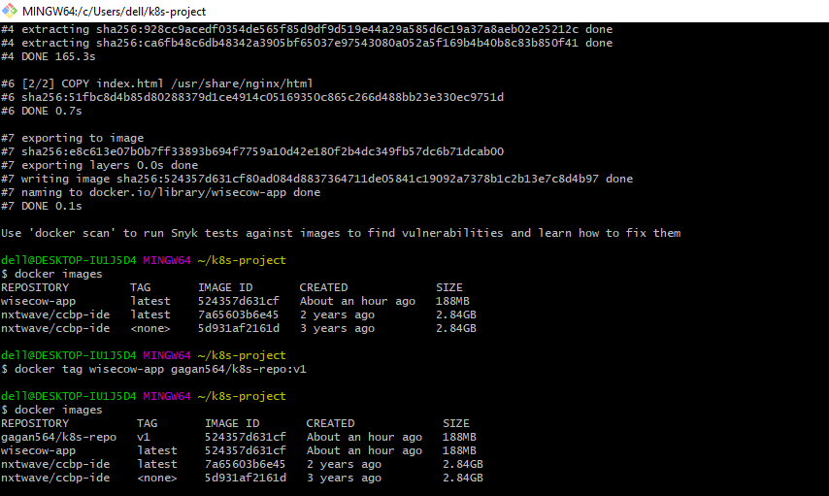

**Create the repository on dockerhub**

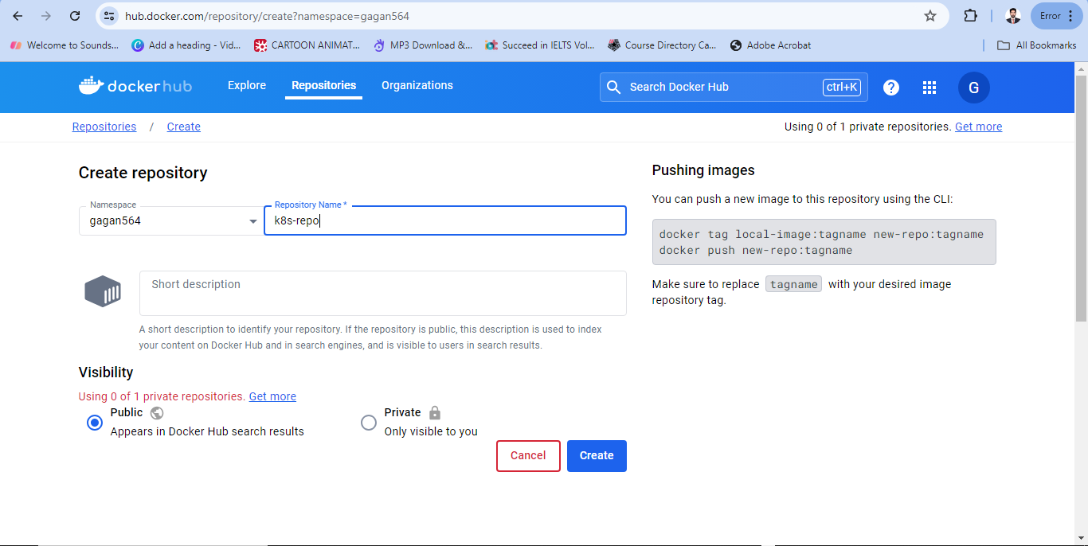

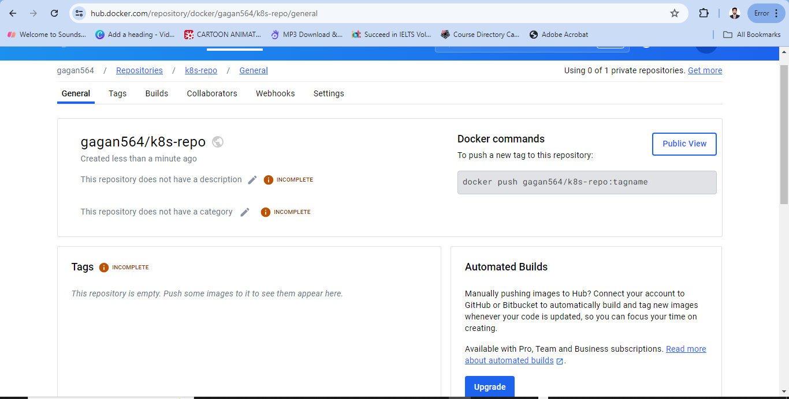

**Now push the docker image**

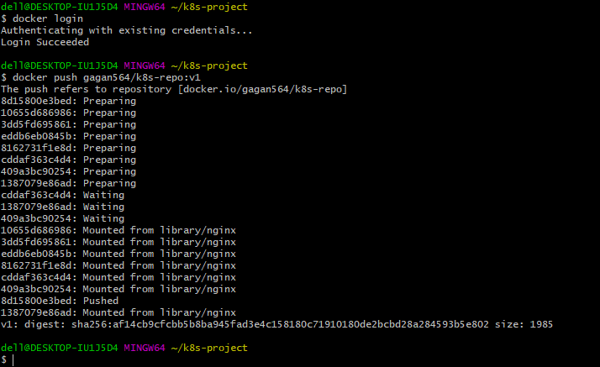

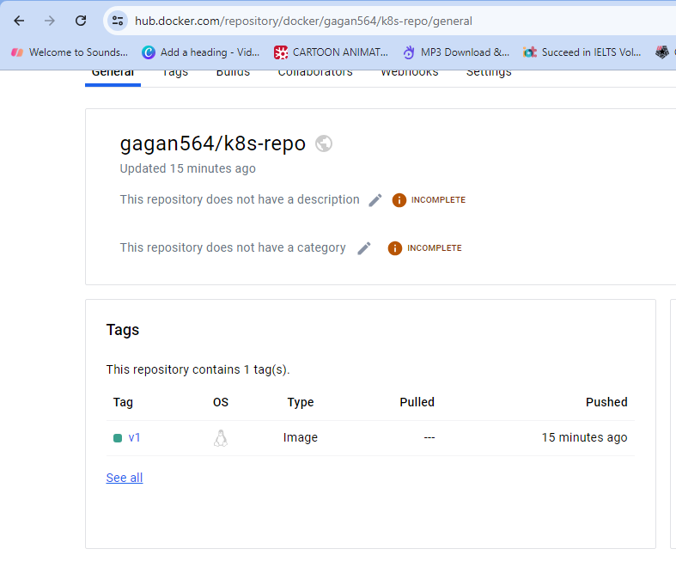

<https://hub.docker.com/layers/gagan564/k8s-repo/v1/images/sha256-af14cb9cfcbb5b8ba945fad3e4c158180c71910180de2bcbd28a284593b5e802?context=repo>

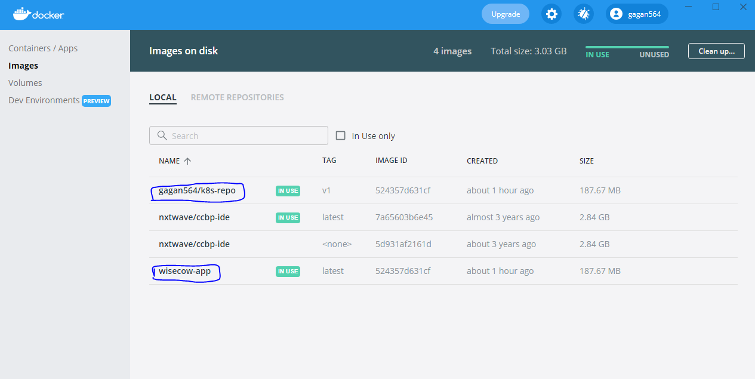

**Now deploy the application to kubernetes cluster**

Run the below commands one by one to deploy the application on kubernetes

Deploy the application using manifest files

Kubectl create deployment app-deploy –image=gagan564/k8s-repo:v1

Kubectl get deploy

Kubectl describe deploy app-deploy

Kubectl get pod

Kubectl describe pod [name of pod]

Kubectl get service

Kubectl get deploy

Kubectl expose deployment app-deploy –port=80 –type=NodePort

Kubectl get svc

Kubectl get nodes -o wide

Kubectl get pod -o wide

At last copy the Ip address of worker node and paste in browser

Now, Application has been deploy successfully on kubernetes